Learning Management System Instructor Job Aid
Contents
Purpose 2
Job Aid Organization 2
Your Tasks 3
Access the Instructor Menu 4
View Course Assignments 5
View Course Information 6
View Site Information 7
Print a Class Roster 8
Print Course Requirements 10
Update Class Attendance 12
Update Pennsylvania Certified Investigator Attendance 14
Create a Course 17
Upload Courseware 20
Create a course module and assign courseware to a module 38
Enroll a student in a course 42
Unenroll a student in a course 49
Batch enroll students 56

Purpose

The Home and Community Services Information System (HCSIS) project is using a Learning Management System (LMS) to assist in training logistics and course creation.

Job Aid Organization
This job aid is organized with the following subsection:
- Your Tasks: The Tasks section outlines the steps necessary to complete this job aid. In addition, this section identifies the HCSIS screens used to complete the tasks.

Your Tasks

As an instructor, you will need to perform the following tasks:
Task | Page Number
Access the instructor menu | 6
View course assignments | 7
View course information | 8
View site information | 9
Print class roster | 10
Print course requirements | 12
Update class attendance | 14
Update Pennsylvania Certified Investigator attendance | 16
Create a course | 19
Upload courseware | 22
Create a course module and assign courseware to a module | 40
Enroll a student in a course | 44
Unenroll a student in a course | 51
Batch enroll students | 58

Detailed instructions are included in this job aid packet. The documentation for each task is divided into the following sections:
Section | Use
Procedure Description | This is a brief summary of the purpose of the screen. It includes the context of this screen within the process.
Dependencies | The steps that precede the start of a procedure.
Screen | This is a screen print of the task to complete.

Access the Instructor Menu

Procedure Description

Use this link to access the Instructor Screen.
Dependencies
- You will not have access to the Instructor Tools until the System Administrator has assigned you the security role of Instructor.
- You must log onto the LMS in the following location: http://www.humanservices-r.state.pa.us/HCSISLMS

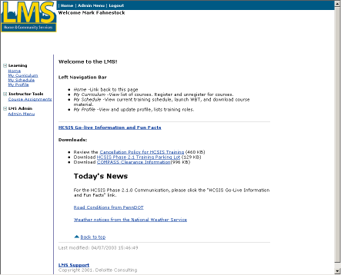
Steps
- Click “Course Assignments” to access courses. If the “Course Assignments” link is not displayed, click the “+” symbol next to “Instructor Tools”.

View Course Assignments

Procedure Description

After you select the Course Assignments link, the LMS displays all courses assigned to you.
Dependency
- Access this screen by clicking the “Instructor Tools” link

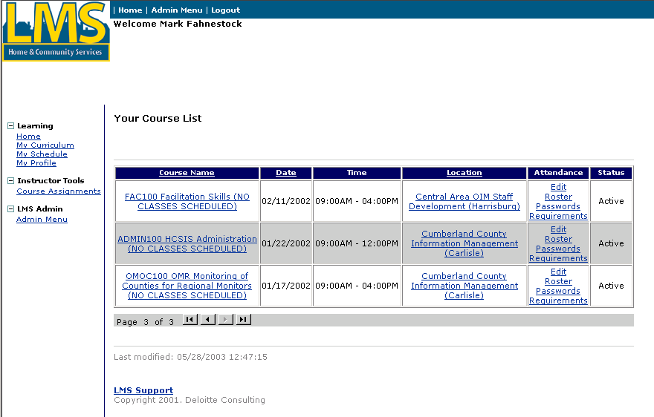
Steps
- You may sort the Course List by clicking on the headings. (ie. Course Name, Date, Location)
- The directional buttons at the bottom of the list allow you to page through your course list.

View Course Information

Procedure Description

The Course Information page allows you to view course description, audience and requirements information.
Dependency
- You must click “Course Assignments” from the Main Menu to access this link.

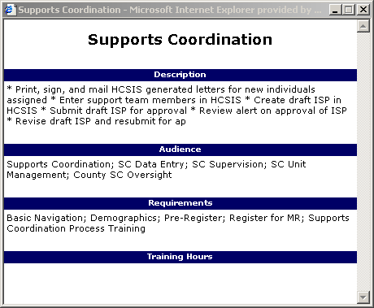
Steps
- Click a course name under the “Course Name” heading on the “Course Assignment” page.
- To close the course information window and return to the “Course Assignment” page, click the “X” in the upper right corner of the window.

View Site Information

Procedure Description

The Site Information page allows you to view facilities information including the room name, facility name and address and contact name, phone and email.
Dependency
- You must click “Course Assignments” from the Main Menu to access this link.

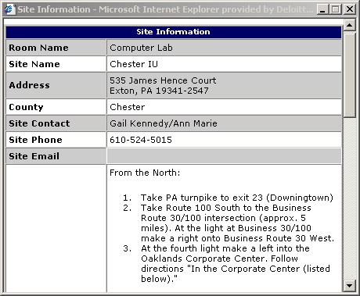
Steps
- Click a site name under the “Location” heading on the “Course Assignment” page
- To close the course information window and return to the “Course Assignment” page, click the “X” in the upper right corner of the window.

Print a Class Roster

Procedure Description

Create a printable class roster in Adobe Acrobat format. Class roster reports include the course name, location, date and time, instructor and assistant instructor and class capacity. The list of students on the report includes the students’ names, login IDs, email addresses and counties.
Dependency
- Click “Course Assignments” from the Main Menu.
Steps
- Click “Roster” under the “Attendance” heading on the “Course Assignment” page.
Print a Class Roster (continued)
The File Download dialog box will display:
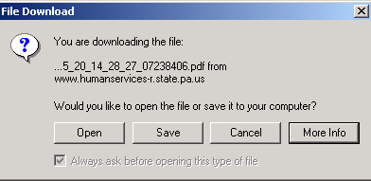
- Click [Save] to save the roster to your hard drive.

Note: Even if you select [Open] from dialog box, you will be prompted to save the file.

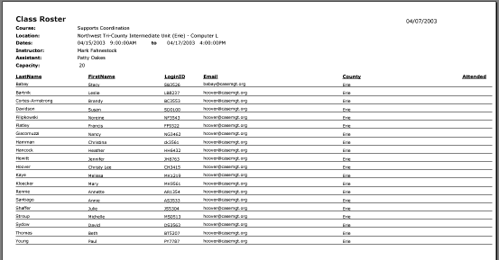
- Print the course roster from the file saved on your local system.

Note: To print a roster with students’ passwords, select “Password” under the “Attendance” heading on the “Course Assignment” page.

Print Course Requirements

Procedure Description

Create a report in Adobe Acrobat format with the course requirements and a listing of students in the class and the courses each one has completed.
Dependency
- Click “Course Assignments” from the Main Menu.
Steps
- Click “Requirements” under the “Attendance” heading on the “Course Assignment” page.

Print Course Requirements (continued)
The File Download dialog box will display:
- Click [Save] to save the report to your hard drive.

Note: Even if you select [Open] from dialog box, you will be prompted to save the file.

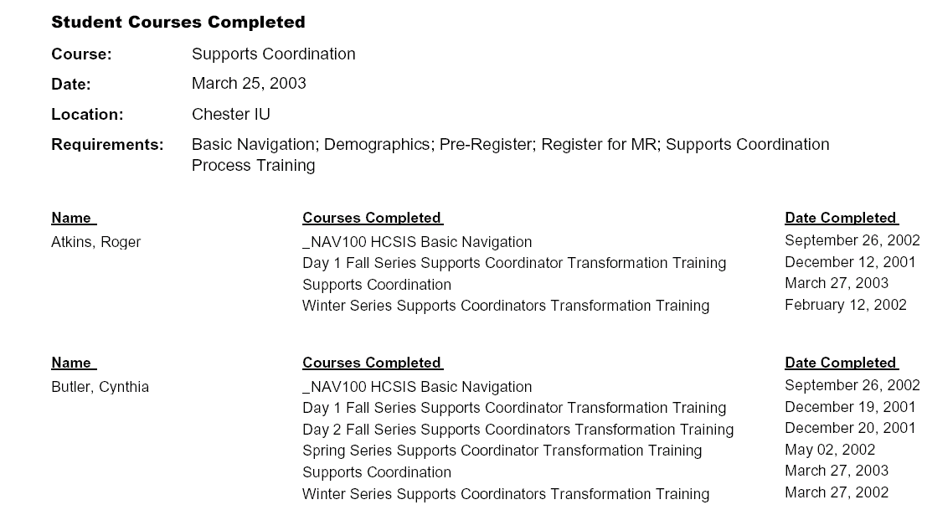
- Print the requirements report from the file saved on your local system.

Update Class Attendance

Procedure Description

The attendance page allows you to check off the students who have attended the class.
Dependencies
- Click “Course Assignments” from the Main Menu.
- Click “Edit” under the “Attendance” heading on the “Course Assignment” page.

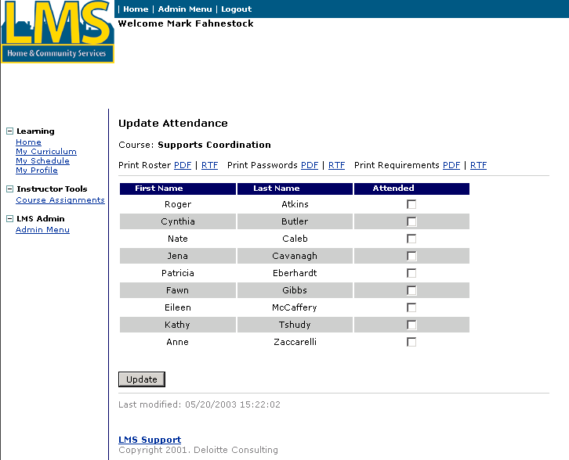
Steps
- Check off the Attended checkbox for each student who has attended the course.
- Click [Update] to update the class attendance.
Update Class Attendance (continued)

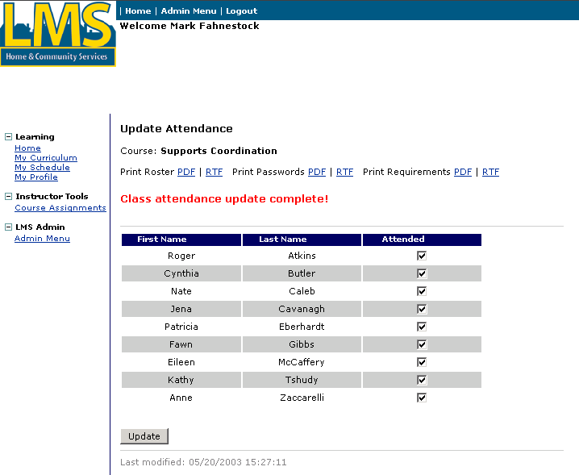

Tip: Fields marked with  are required fields and must be completed in order to save information on the screen.
- The “Class Attendance Update Complete!” message displays.
- You may also generate the Roster, Roster with Passwords or Course Requirements report in either Adobe Acrobat (PDF) or Rich Text Format (RTF) using the links at the top of this page.

Note: There is only one checkbox per student per class even if the class has multiple days.

Update Pennsylvania Certified Investigator Attendance

Procedure Description

The Pennsylvania Certified Investigator instructor enters attendance, form submission and exam scores for students that have registered for the Pennsylvania Certified Investigator Exam or the Pennsylvania Certified Investigators Re-certification Course on the Attendance page. After the information for the class participants has been entered, the instructor sends emails to the participants informing them of their certification status using the link on the Attendance page. The instructor may also use the links to send individual results.

Note: The procedure for updating attendance for the Pennsylvania Certified Investigator Course is the same as for all other courses.
Dependencies
- Click “Course Assignments” from the Main Menu to access the “Course Assignments” page.
- Click “Edit” under the “Attendance” heading on the “Course Assignments” page.
Update Pennsylvania Certified Investigator Attendance (continued)

The Update Attendance page displays.
Tip: The Exam Score column will not display for the Re-certification Course. There is no exam for that course. However, participants must submit the appropriate form to be re-certified.
Steps
- Check the “Attended” checkbox for each student who has attended the course.
- Enter the student’s exam score in the Exam Score field. (See Tip box).
- Check the “Form Submitted” checkbox for each student who submitted the appropriate form.
- Click [Update] to update the class information. The “Class attendance update complete!” message displays.
- Click ‘Send Exam Results’ or ‘Send Course Results’ to email certification status to all students or click ‘Send’ to email certification status to individual students.
Note: Be sure to click [Update] BEFORE sending the emails so that the information will be saved and the emails will be correct.
Update Pennsylvania Certified Investigator Attendance (continued)

The following screen displays confirming the email(s):
Tip: The confirmation for the Re-certification course will read, “Re-certification Completion Information Sent!”

Create a Course

Procedure Description

Create new course information (including description, audience and requirements) using the “Admin Menu”. After you have created a course, you can create courseware and associate it with the new course. The Logistics Manager creates the course offerings and assigns roles to the course.

After you click “Admin Menu”, the LMS Administration Menu page displays. This is the page that displays all of the functions within the LMS Administration Menu.

Your LMS Administration menu contains the following sections:
- Instructor-led Courses
- Web based training
- Reporting
Dependency
- Click “Admin Menu” to access this page.

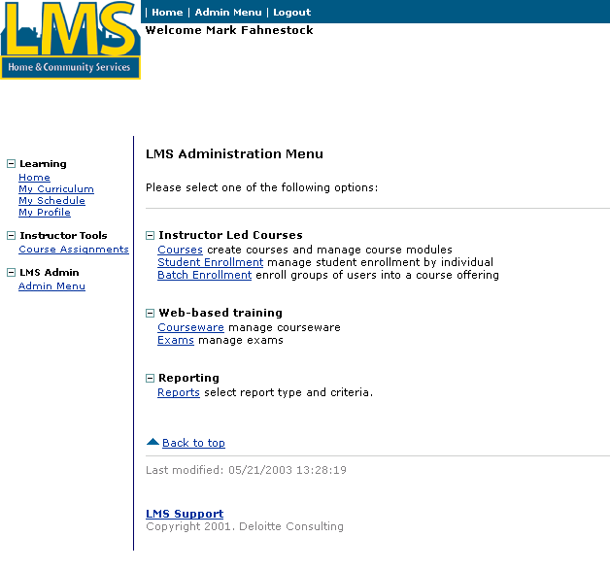
Steps
- Click “Courses.”

Create a Course (continued)

The following screen displays:

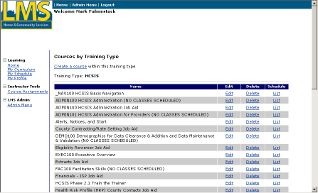
- Click “Create a course.”
Create a Course (continued)

The following screen displays:

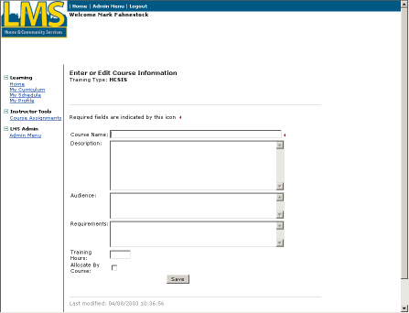

Tip: Fields marked with  are required fields and must be completed in order to save information on the screen.
- Complete the following fields:
Course Name | Enter the Name of the course, beginning with the course ID as it should appear on the “My Curriculum” and “My Schedule” pages.
Description | Enter a brief description of the course, including course objectives.
Audience | List the roles that should attend this course.
Requirements | List the prerequisites in order to take this course.
Training Hours | Leave this field blank unless this course qualifies as continuing education credits.
Allocate By Course | Check this field if you wish to allocate a specific number of seats to each entity.
- Click [Save].

Upload Courseware

Procedure Description

Courseware is created in a separate program and then uploaded to the LMS and associated with a course. Courseware may be a single file such as a Microsoft Word document, a Click2Learn Web based training course or a Microsoft PowerPoint presentation. Courseware is uploaded to the course from “Admin Menu.” The process for each type of upload varies slightly.
Dependencies
- A course must be created in the Learning Management System.
- Courseware is created in a separate program.
- Click “Admin Menu” to access this page.

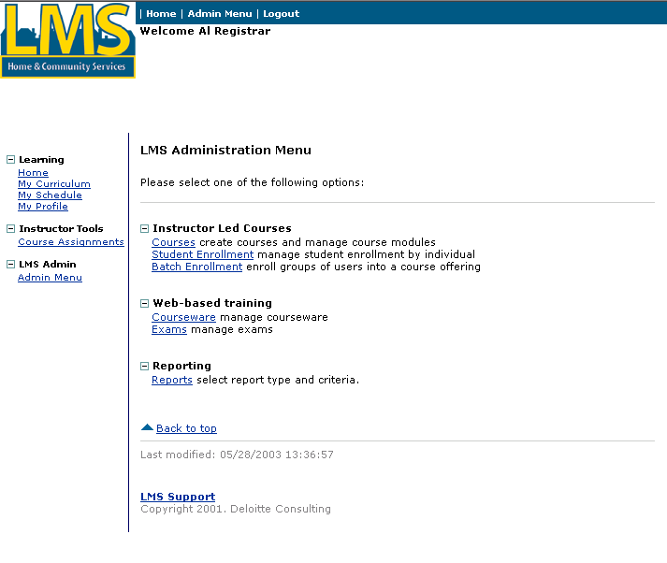
Steps
- Click “Courseware.”
Upload courseware (continued)

The following screen displays:

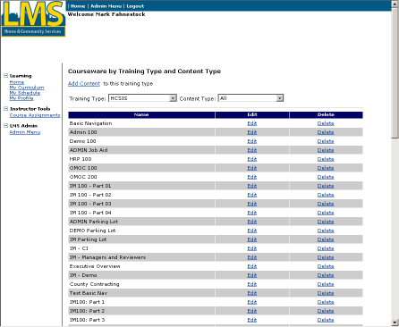
- Click “Add Content.”
Upload courseware (continued)

The following screen displays:

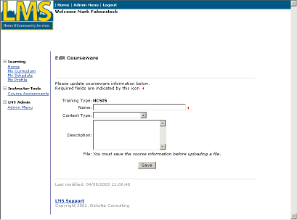
- Complete the following fields:
Name | Enter the name of the courseware. This is the name that is listed when you are choosing courseware to attach to a module.
Content Type | Select the type of courseware. Note: For a single file such as a Word document, choose “Zipped Executable”.
Description | If desired, enter a description about the courseware.

- Click [Save].
Upload courseware (continued)

The following screen displays:

The new courseware appears in the list.
- Click “Edit” to the right of the courseware to upload courseware content.

Note: The process differs slightly depending on the type of courseware content. The next three sections will explain the steps specific to:
  - Click2Learn Toolbook courses
  - A single file such as a Word document
  - A multiple file presentation
Upload courseware (continued)
Upload a Click2Learn Toolbook course
Dependency
- The content type for the courseware must be saved as “Toolbook”.

The following screen displays:

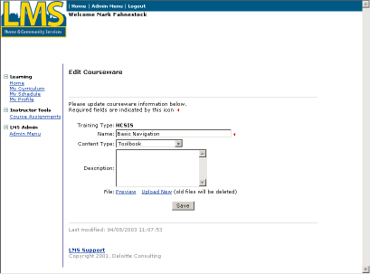
Steps
- Click “Upload New.”
Upload courseware (continued)
Upload a Click2Learn Toolbook course (continued)

The following screen displays:

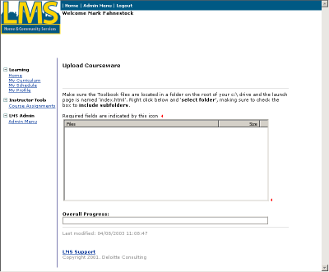
- Using the mouse, right click in the white area of the File box.
Upload courseware (continued)
Upload a Click2Learn Toolbook course (continued)

This menu appears on the screen:
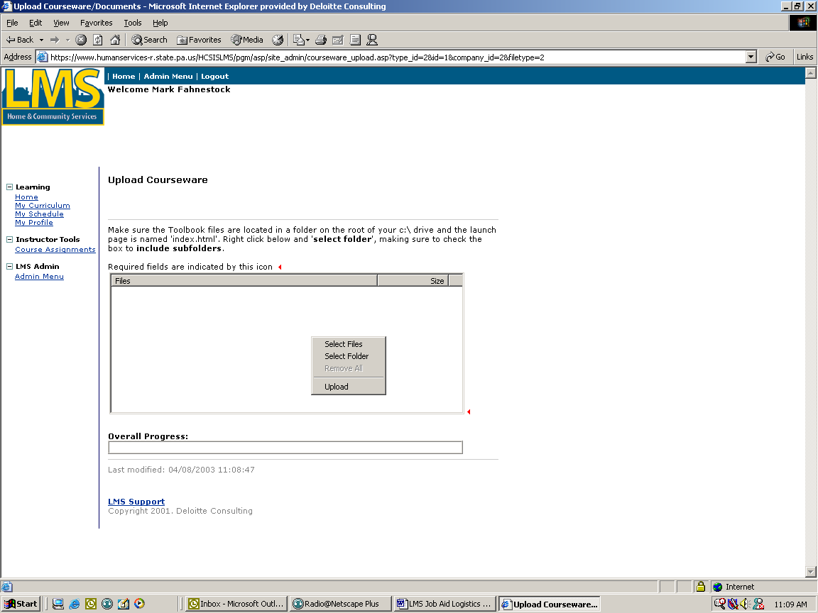
- Click “Select Folder”.
Upload courseware (continued)
Upload a Click2Learn Toolbook course (continued)

The following window displays:

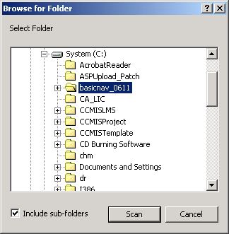
- Select the folder for the Toolbook course.
- Check the “Include sub-folders” checkbox.
- Click [Scan]
Upload courseware (continued)
Upload a Click2Learn Toolbook course (continued)

The files display in the file box.

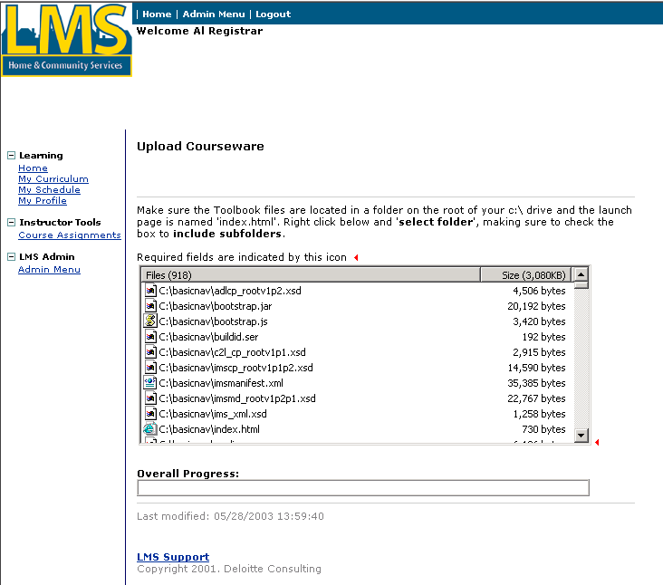
- Using the mouse, again right click in the file box.
Upload courseware (continued)
Upload a Click2Learn Toolbook course (continued)

The following screen displays:

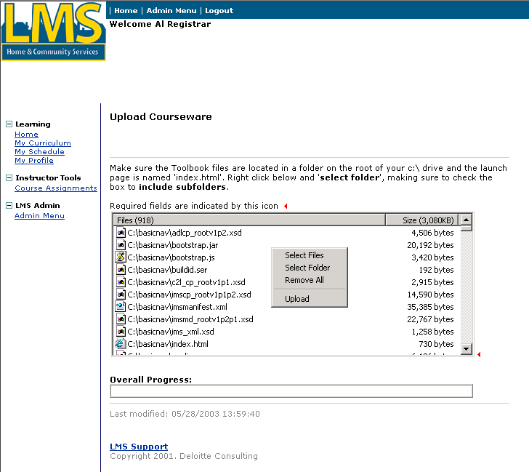
- Click “Upload”.

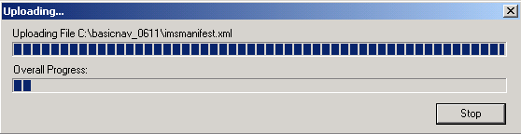

This window displays the progress of the files uploading to the Learning Management System. The process can take several minutes and is complete when the bars reach the right side of the box. The screen then automatically redirects to the “Edit Courseware” screen where you can preview the course. If an error occurs, contact the HCSIS Help Desk.

Upload courseware (continued)
Upload a single file
Dependency
- “Zipped Executable” must be saved as the Content type.
Steps
- Create or edit a courseware record (pages 20 to 22).
- Follow the steps on pages 23 to 25 to select the courseware and display the upload screen.

This menu appears on the screen:
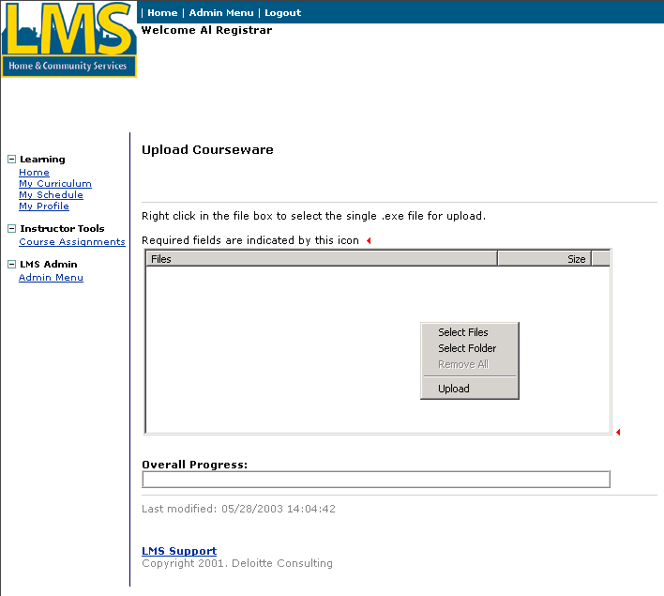
- Using the mouse, right click in the white are of the File box.
- Click “Select Files.”
Upload courseware (continued)
Upload a single file (continued)

The following screen displays:

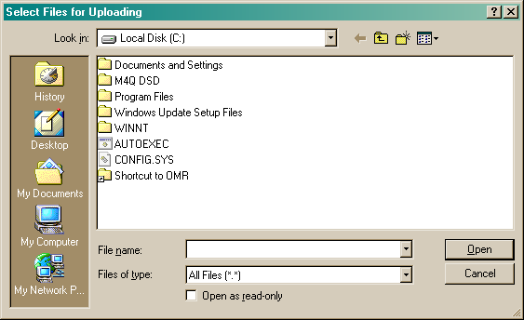
- From this screen, choose the file to upload. You may need to click “My Network Places” or “My Documents” to choose the file in the appropriate folder.
- Select the file and click [Open].
Upload courseware (continued)
Upload a single file (continued)

The file displays in the File box.
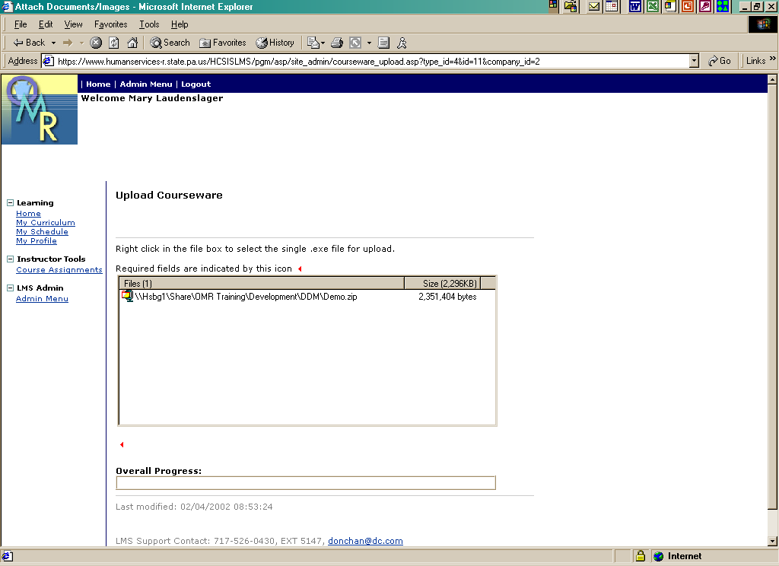
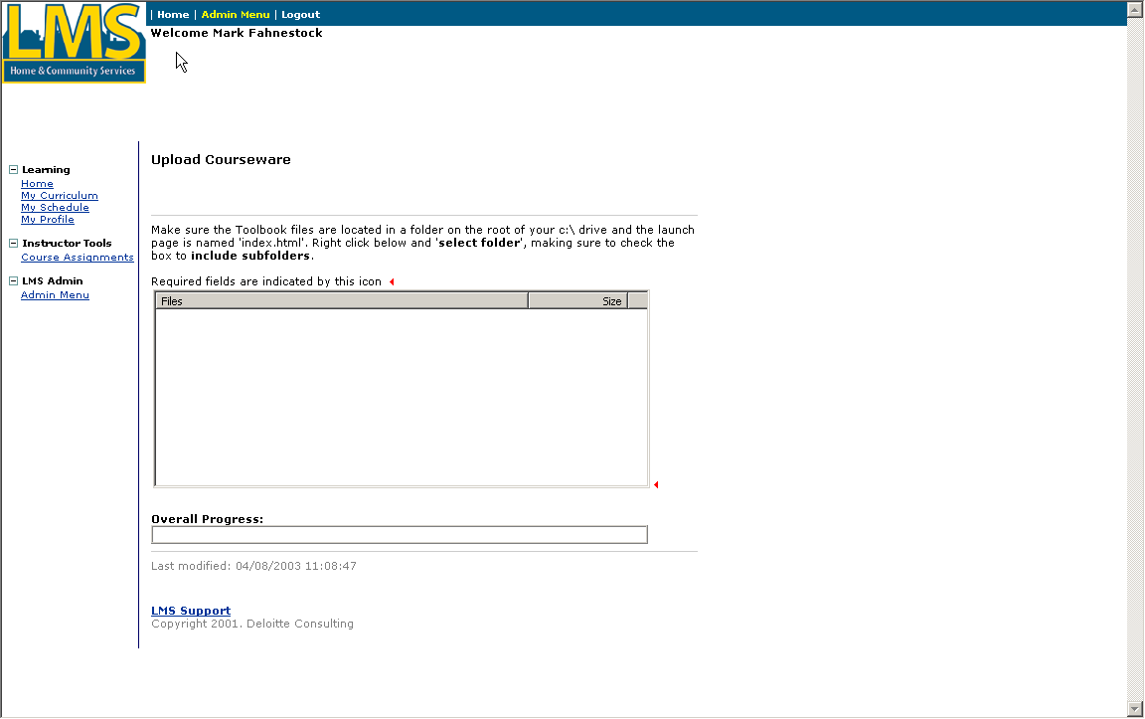
- Using the mouse, again right click in the File box.
Upload courseware (continued)
Upload a single file (continued)

The following menu displays:
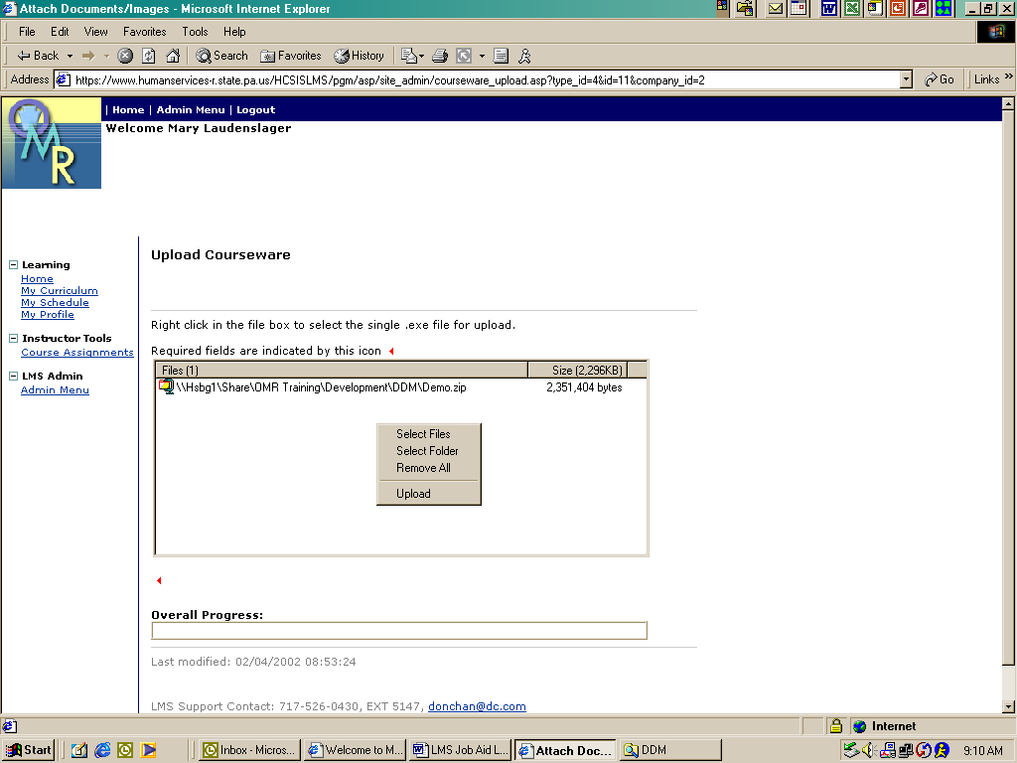
- Click “Upload.”

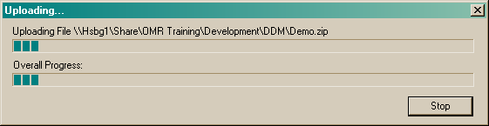

This window displays the progress of the file uploading to the Learning Management System. The process may take several minutes and is complete when the bars reach the right side of the box. The screen then automatically redirects to the “Edit Courseware” screen where you can preview the course. If an error occurs, contact the HCSIS Help Desk.

Upload courseware (continued)
Upload a Multiple File Presentation

This option can be used to upload a demo or presentation that requires multiple files, for example Power Point or an HTML walkthrough.
Dependency
- PowerPoint must be saved as the Content type on the “Edit Courseware” screen.
Steps
- Create or edit a courseware record (pages 20 to 22).
- Follow the steps on pages 23 to 25 to select the courseware and display the upload screen.

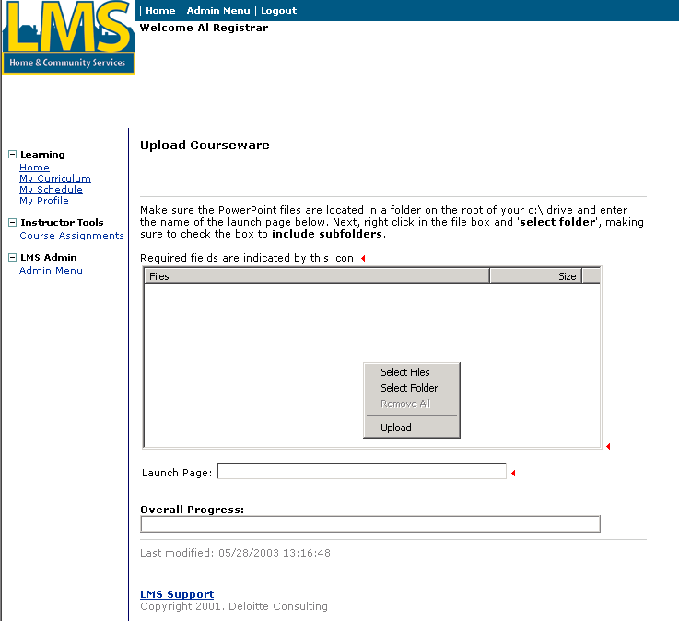
- Using the mouse, right click in the File box.
- Click “Select Folder”.

Upload courseware (continued)
Upload a Multiple File Presentation (continued)

The following window displays:

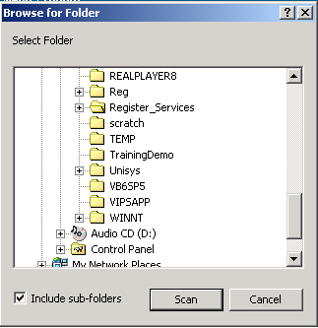
- Select the folder for the Presentation.
- Check the “Include sub-folders” checkbox.
- Click [Scan]
Upload courseware (continued)
Upload a Multiple File Presentation (continued)

The files display in the File box.

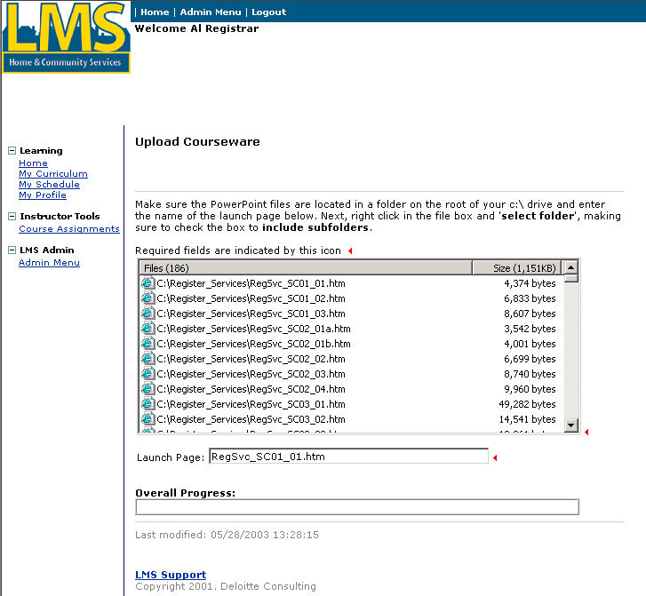
- Enter the name of the file that starts the presentation or demo in the box labeled “Launch Page”.
- Using the mouse, again right click in the File box.
Upload courseware (continued)
Upload a Multiple File Presentation (continued)

The following menu displays:

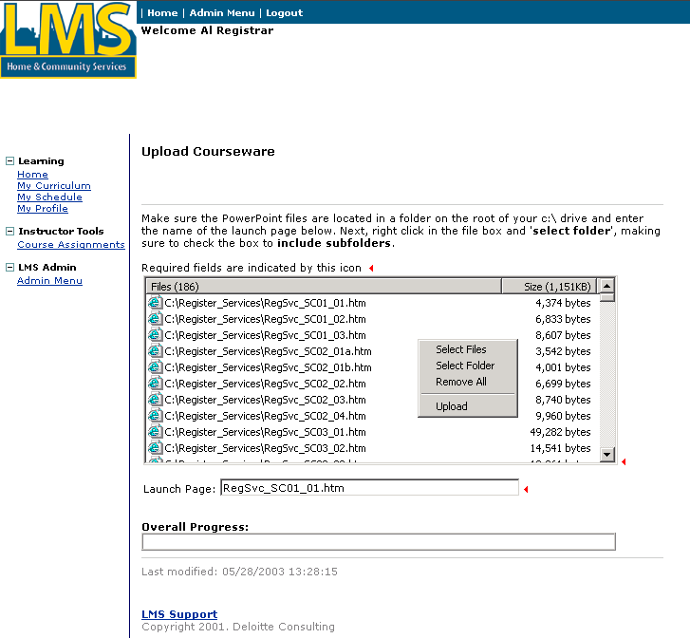
- Click on “Upload”.

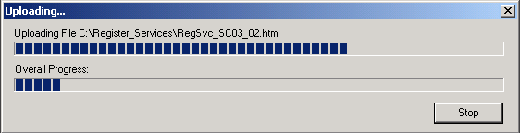

This window displays the progress of the file uploading to the Learning Management System. The process may take several minutes and is complete when the bars reach the right side of the box. The screen then automatically redirects to the “Edit Courseware” screen where you can preview the course. If an error occurs, contact the HCSIS Help Desk.

Create a course module and assign courseware to a module

Procedure Description

After the courseware is uploaded into the Learning Management System, the courseware is linked to a course using a module. Courseware is linked to the course from “Admin Menu.”
Dependencies
- A course must be created in the LMS.
- Courseware must be uploaded to the LMS.
- Click “Admin Menu” to access this page.
Steps
- Click “Courses.”

Create a module and assign courseware to a module (continued)

The following screen displays:
- Click “Edit” to the right of the course in which to link courseware.
Create a module and assign courseware to a module (continued)

The following screen displays:

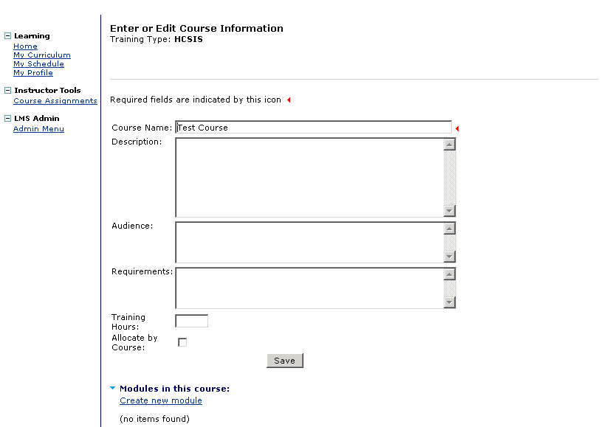
- Click “Create New Module.”
Create a module and assign courseware to a module (continued)

The following screen displays:

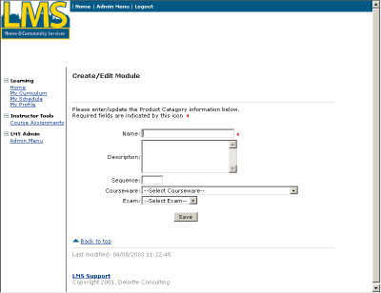
- Complete the following fields:
Name | Enter the name of the course module.
Description | If desired, enter a description about the course module.
Sequence | Enter a 1 to denote that this is the first course module for this course. Enter other numbers for sequential course modules.
Courseware | Select the appropriate courseware from the dropdown box.
Exam | Select from the dropdown box if applicable.

- Click [Save].

Enroll a student in a course

Procedure Description

After a course is created and has course offering linked to it by the Logistics Manager, you can enroll students in the course offering. Enroll students in the course from “Admin Menu.”
Dependencies
- A course must be created in the Learning Management System.
- A course offering must be linked to the course in the Learning Management System.
- A student must be registered in the Learning Management System.
- Click “Admin Menu”.

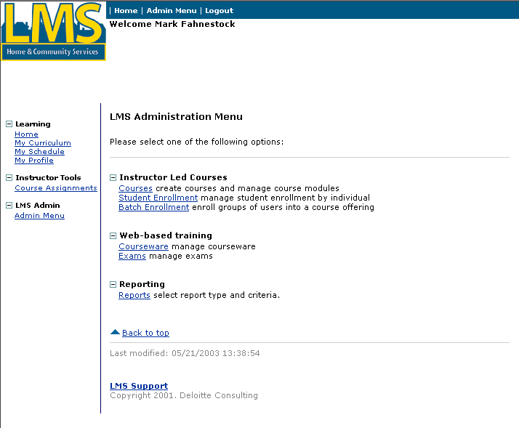
Steps
- Click “Student Enrollment.”

Enroll a student in a course (continued)

The following screen displays:

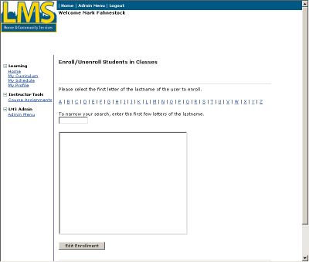
- Select the first letter for the student’s last name.
- Next, you may either type the first few letters of the user’s last name or you may scroll through the list of all users.
- Click the user name to select it.
- Click [Edit Enrollment].
Enroll a student in a course (continued)
The following screen displays:
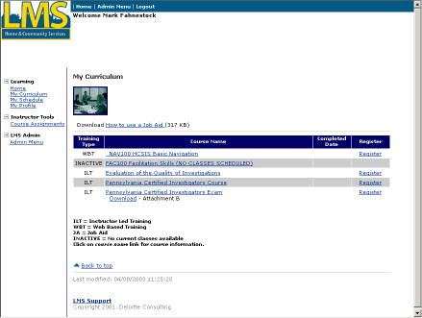

This screen lists available courses for the student in which to enroll. Courses are determined by the role of the student. Students are assigned roles by their registrar.
- Click “Register” to the right of the course in which to enroll the student.
Enroll a student in a course (continued)

The following screen displays:

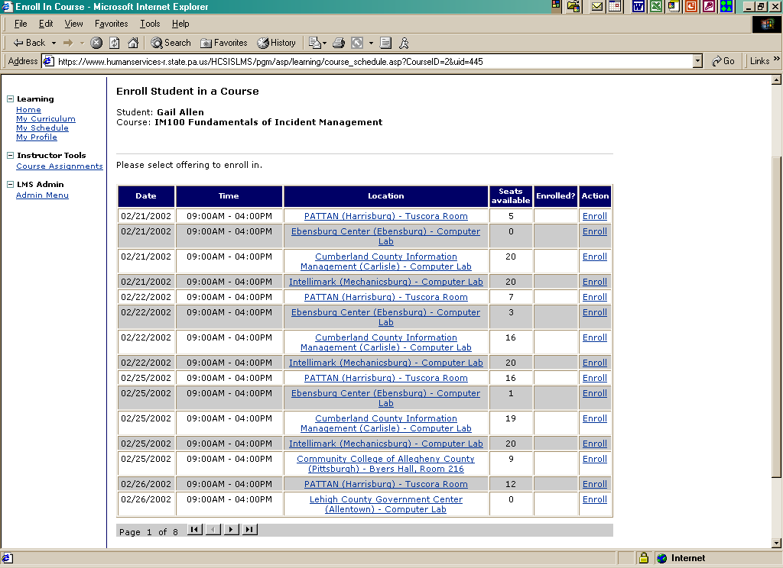

This screen lists the possible class dates and locations for the course. The Seats Available column lists the number of seats left in the class. If Seats Available equals 0, then the course has met its seating capacity.
- Click “Enroll” to the right of the class date and location in which to enroll the student.

Note: If “Enroll” does not appear in the Action column, the student is currently enrolled in another class. Before you can enroll this student in a new class, you must unenroll them from the other class.

Note: If seats are allocated by course, you may see the message, “There are no allocated seats remaining for {student’s entity}.” You can override and enroll the student in the course.

Note: If seats are allocated by course offering, only the course offerings that are not allocated or are allocated to the student’s entity will display in the list.
Enroll a student in a course (continued)

The following screen displays:

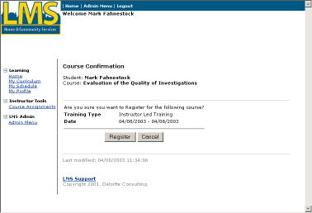

This screen confirms the registration of the class for the student.
- Click [Register] to confirm the class registration. If the student should not be registered for the listed class, click [Cancel].
Enroll a student in a course (continued)

The following screen displays:

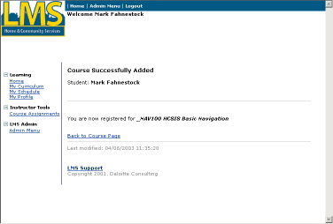

The student has been successfully registered for a class.
- Click “Back to Course Page.”
Enroll a student in a course (continued)

The following screen displays:

Unenroll a student in a course

Procedure Description

Unenroll students from a course offering using the “Admin Menu.”
Dependencies
- A course must be created in the LMS.
- A course offering must be linked to the course in the LMS.
- A student must be registered in the LMS.
- A student must be enrolled in a course offering in the LMS.
Steps
- Click “Student Enrollment.”
Unenroll a student in a course (continued)

The following screen displays:
- Select the first letter for the student’s last name.
- Next, you may either type the first few letters of the user’s last name or you may scroll through the list of all users.
- Click the user name to select it.
- Click [Edit Enrollment].
Unenroll a student in a course (continued)
The following screen displays:

This screen lists all available courses for the student.
- Click “Register” to the right of the course in which to unenroll the student.
Unenroll a student in a course (continued)

The following screen displays:

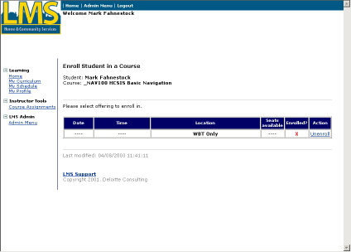

A red X appears to the right of the course that the student is currently enrolled.
- Click “Unenroll” to the right of the course offering in which to unenroll the student.
Unenroll a student in a course (continued)

The following screen displays:

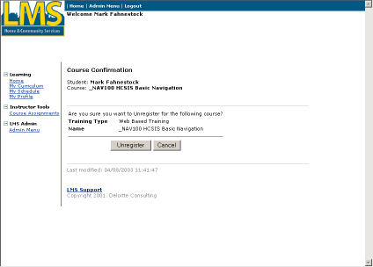

This screen confirms the unenrollment from the course offering for the student.
- Click [Unregister] to confirm the unenrollment. If the student should remain enrolled in the listed course offering, click [Cancel].
Unenroll a student in a course (continued)

The following screen displays:

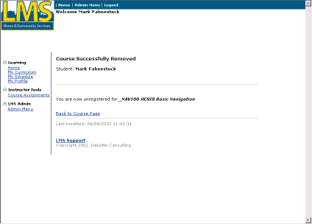

The student has been successfully removed from a class.
- Click “Back to Course Page.”
Unenroll a student in a course (continued)

The following screen displays:

Batch enroll students

Procedure Description

Several students with the same role can be registered for a course offering simultaneously. This process is called batch enrollment. Students are batch enrolled for the course from “Admin Menu.” In the LMS, a “course offering” refers to a specific location and time for which the course will be taught.
Dependencies
- A course must be created in the LMS.
- A course offering must be linked to the course in the LMS.
- Students must be registered in the LMS.
- Click “Admin Menu”.
Steps
- Click “Batch Enrollment.”
Batch enroll students (continued)

The following screen displays:

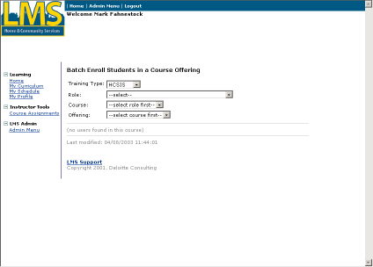
- Select the appropriate role for the course in the Role drop down box.
- Select the appropriate course from the Course drop down box. The courses listed are the ones associated with the role that was chosen in the previous box.
Batch enroll students (continued)

The following screen displays:
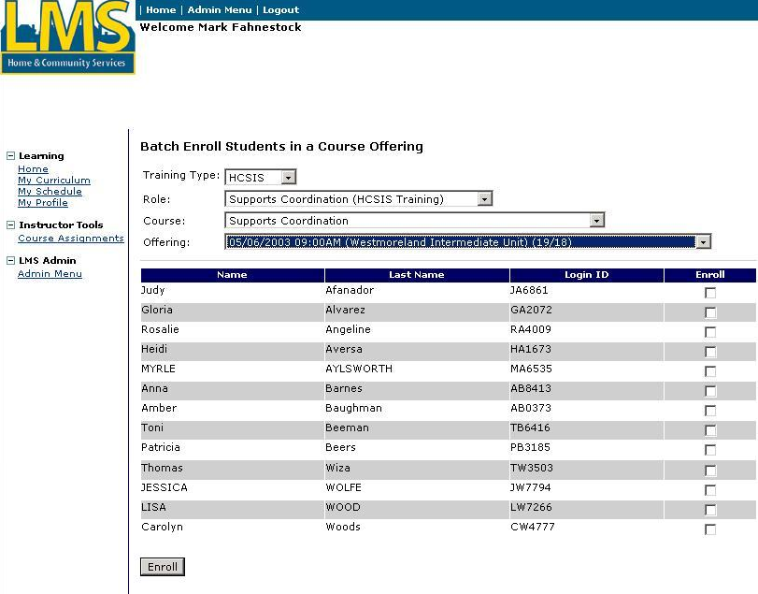
This screen lists all students who have been registered in the Learning Management System with the role that was selected and are not currently enrolled in the selected course.
- Select the class date and time in the Offering drop down box. The fraction indicates how many seats are taken per how many seats are available.
- Click in the box(es) to the right of the student(s) to enroll in the class.
- Click [Enroll].
The screen listed above displays again if there are students with the selected role that are not yet enrolled in the course. You can choose another course offering and enroll more students.
You have completed this job aid.

